Contents
1. Introduction: 1
1.1 The Evolution of Business Intelligence 1
1.2 Purpose and Scope 1
2. Question 1: Critical Appraisal of the Dashboard: 1
2.1 Identifying Key Strategic Insights 1
2.2 Insight 2: Profitability Volatility and Product Mix 2
3. Evaluating Predictive Analytics for Executive Decision-Making 2
3.1 Transitioning from Descriptive to Forward-Looking Intelligence 2
3.2 Two Primary Ways Predictive Insights Enhance Executive Decision-Making: 3
3.2.1 Advanced Sales and Demand Forecasting: 3
3.2.2 Customer Sentiment and customer Churn: 3
3.3 Institutional Requirements to Support Predictive Capabilities 4
3.4 Possible Concerns and Ethical issues 4
4. Strategic Recommendations and Conclusion 5
4.1 Maximizing Opportunities and Minimizing Risks 5
4.2 Short-Term and Medium-Term Action Plan 5
4.3 Conclusion 5
References (APA Style) 6

1. Introduction:
1.1 The Evolution of Business Intelligence
Through the Fourth Industrial Revolution age of the modern era, data has ceased being a byproduct of the business processes and has become the most vital strategic resource of an organization. The impact of Business Intelligence (BI) and Data Analytics on the way corporations operate has changed the paradigm of decision-making, as it is no longer about intuition-based but evidence-based strategies. The report is concentrated on the Sample Superstore dataset that can be considered an ideal case of a multi-regional retail company with complicated problems of sales, logistics, and profitability. (Gressel, Pauleen, & Taskin, 2020)
1.2 Purpose and Scope
The assessment will attempt to emulate a high level boardroom situation whereby data is utilized to motivate executive action. In this case as an Executive Advisor, the challenge is a critical analysis of the available performance dashboards. Although descriptive analytics (what has happened) is a starting point, the last objective of a Master of Science in Business Analytics student lies in filling the gap between the past and the future. In this report, the existing KPIs will be critically evaluated, and the incorporation of Artificial Intelligence (AI) and Predictive Analytics to improve the dashboards will be assessed and potential dashboard improvements that will serve as the 360-degree view of the business will be proposed. It is upon the completion of this analysis that the board will have an explicit roadmap on how to optimize the performance of the region and reduce the risk of operations.

2. Question 1: Critical Appraisal of the Dashboard:
2.1 Identifying Key Strategic Insights
A dashboard is not just any collection of charts, it is a storytelling tool of C-level executives (CEO, CFO, COO). After a close analysis of the existing Tableau dashboard of the Sample Superstore, it is possible to identify two main insights that need to be addressed by the executive. (Knaflic, 2015)
Perception 1: Local Inequality and Market Monopoly.
The sales per region analysis shows that the West and East regions have a very high concentration of revenue. The regional West especially has a strong sales performance of over $700,000.
- Detailed Analysis: This indicates that the market penetration strategies at these locations are very successful. The blaring poor performance of the South region however points to a leakage in the markets or failure in regional branding. The questions the executives need to pose are: Is it the product-market fit that is wrong in the South or is the supply chain cost in the region eliminating the competitive advantage?
- Strategic Decision Support: These are insights to aid a decision of in nature of resource reallocation. The board must instead think of a "Tiered Investment Strategy" the West should be considered as a Cash Cow to stabilize, and the South a Question Mark that needs strategic pivot or a localized discount model to achieve market share.
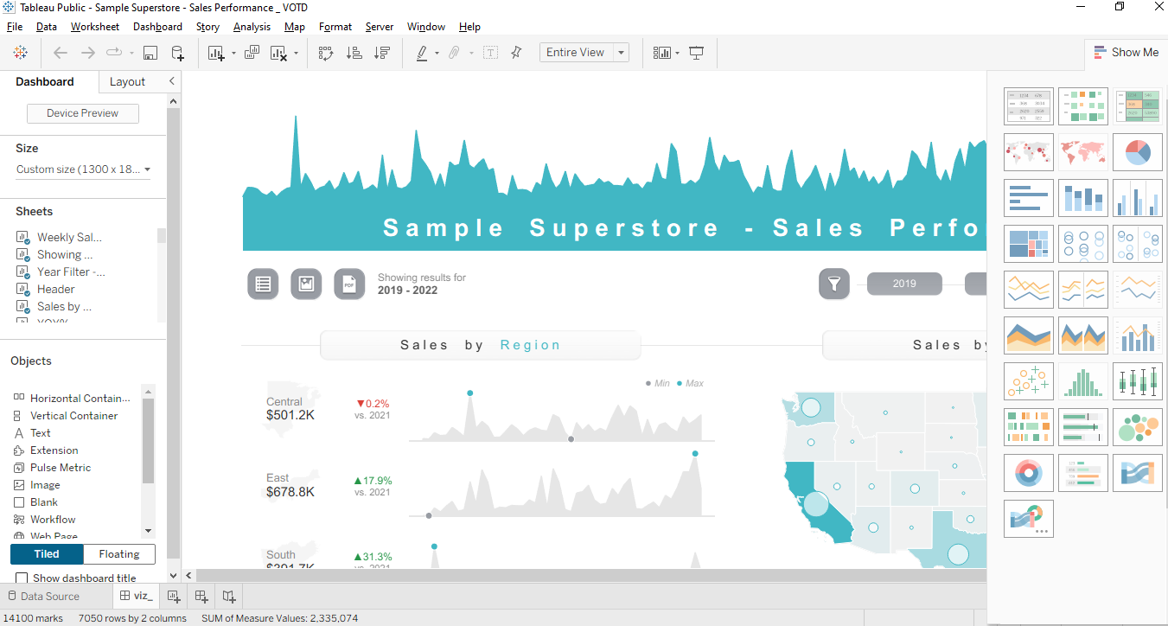
2.2 Insight 2: Profitability Volatility and Product Mix
The current dashboard makes it clear that the level of sales is not always associated with the high profitability. Namely, in some of sub-categories such as Furniture or Tables, the profit margins are so slim or even negative in some of the quarters.
- Detailed Analysis: This is an important insight to the CFO. It shows that the income is being negated by the Cost of Goods Sold (COGS) or the Shipping Costs of the heavy goods. The highest profit at the end of 2021 can serve as a benchmark; this is the time when it is possible that the product mix was optimized or there were low promotion expenses.
- Operational Decision Support: This contributes to the decision of "Prune the Product Portfolio." With this kind of data, executives are able to pinpoint what they call Value Destroyers products that occupy warehouse space, but do not add to the bottom line. It is advised that a change to a more of a Margin-First approach rather than a Revenue-First approach is made.

3. Evaluating Predictive Analytics for Executive Decision-Making

3.1 Transitioning from Descriptive to Forward-Looking Intelligence
The primary limitation of traditional business dashboards is their reliance on descriptive analytics, which essentially functions as a "post-mortem" of business activities. Descriptive analytics explains what has already happened—total sales last month, profit margins in the previous quarter, or regional performance over the past year. While this information is foundational, it is akin to driving a vehicle by only looking at the rearview mirror. For C-level executives operating in a volatile global market, the true value of data lies in its ability to provide "Forward-Looking Intelligence."
Predictive analytics represents a strategic paradigm shift. By moving from descriptive to predictive, an organization transitions from a reactive stance to a proactive strategy. Instead of reacting to a dip in sales after it has occurred, executives can use historical patterns to anticipate market shifts before they manifest. In the context of the Sample Superstore, this means leveraging the vast repository of transactional data to identify hidden correlations and trends that human intuition might overlook. This shift empowers the board to steer the company toward growth opportunities with statistical confidence. (Anderson & Zettelmeyer, 2020).

3.2 Two Primary Ways Predictive Insights Enhance Executive Decision-Making:
3.2.1 Advanced Sales and Demand Forecasting:
Advanced demand forecasting is one of the most revolutionary uses of predictive analytics. The dashboard can use the future revenue streams with high precision by directly combining advanced time-series models, e.g., the ARIMA or Prophet algorithm, directly into the Tableau environment.
- Strategic Impact: Take the case of West region which our analysis revealed to be a high performing territory. When a predictive model predicts that there will be a 20 percent increase in demand of Technology products in the next quarter, the implication on the Chief Operating Officer (COO) is enormous. The organization can practice an active Inventory Management instead of waiting to receive orders before they accumulate. This is by locking away warehouse space and optimising logistics routes ahead of time. In this manner, the company will not have to face Stock-outs that cost the company in terms of lost revenue and Overstocking that costs the company a valuable capital. Predictive forecasting is basically transforming the supply chain into a strategic competitive advantage center.
3.2.2 Customer Sentiment and customer Churn:
The customer churn Analysis is the second pillar of predictive intelligence that involves using machine learning classification algorithms. Customer retention in a retail setting is usually much less expensive than customer acquisition.
- Strategic Impact: Predictive models can be used to set a "Churn Probability Score" on each account by examining purchase frequencies and average order values. The executives can then be in a position to visualize these scores so as to identify At-Risk customers-those who are likely to cease their purchasing within the next few months. This will enable the Chief Marketing Officer (CMO) to shift away in general promotions to Precision Marketing. As opposed to providing discounts to the whole database, the board will be able to approve targeted loyalty interventions to high-value customers that are likely to churn. This is a strategic blow that secures the base of revenue and also the wasteful marketing costs are cut to a greater extent.

3.3 Institutional Requirements to Support Predictive Capabilities
The adoption of predictive analytics is a holistic change that needs to occur in the institution. To make the board trust these AI-driven features, the following two conditions ought to be satisfied:
- Unified Data Infrastructure: Data models only predictive models are as good as the data poured into them. The company should shed off the Data Silos where sales and finance data are stored in different systems. A Single Source of Truth (SSOT) is necessary to have high accuracy. This means making an investment in centralized data governance so that the data is real time, ethically sourced and clean. In the absence of this base, the predictive models will generate impaired models.
- Human Capital and Tool Integration: Technology in itself cannot turn a boardroom into a smart place. Data Translators are required, people who are knowledgeable not only in machine learning but also in the business strategic requirements. Besides, the dashboard needs to encourage advanced integration, e.g., TabPy, which enables the store to execute complex Python code in the background and present simplified visual outcomes to enable the executive to act.

3.4 Possible Concerns and Ethical issues
Although these benefits are strong, the board should be aware of the risks involved. Predictive analytics is an augmentation tool and not a judgment one.
- The Black Box Problem: There are a lot of Black Boxes in AI, which is the lack of transparency in their decision-making process. This may result in lack of trust at the boardroom. To reduce this, the organization ought to pursue what is known as Explainable AI that will ensure that there is a clear explanation as to why the prediction will be made.
- Algorithmic Bias: In case past data have a bias, a predictive model will enhance it. This may result in unhealthy business activities. The board should make sure that audits are routinely conducted to uphold the morals.
- Black Swan Events: Predictive models make the assumption that the future is like the past. They tend to be oblivious to Black swan events--high stakes events that are hard to predict such as a pandemic. Strategic blindness can occur due to over dependence on models. Thus, executives should apply these knowledge to shape their vision but leave the capability to change directions according to human senses.

4. Strategic Recommendations and Conclusion

4.1 Maximizing Opportunities and Minimizing Risks

In order to optimize the growth, the board should focus on the West region and on Technology category as the key revenue and profit centers of the organization. A Market Penetration strategy would be implemented in the high performing regions in order to cement dominance. At the same time, risks in the South region need to be alleviated by the board. The sales in this territory are low consistently which implies that there is the need to have a localized strategic audit that will help in establishing competitive or logistical challenges. Moreover, the Sales vs. Profit scatter plot demonstrated that certain operations are made at a loss by the operational costs against the revenues. In order to reduce such financial leakages, the board has to exercise tight Profitability Thresholds and re-evaluate the pricing or feasibility of the loss-making sub-categories which the dashboard would have pointed out. (Anderson & Zettelmeyer, 2020)

4.2 Short-Term and Medium-Term Action Plan
Sales by Region (Enhanced Bar Chart): This chart will give an in-depth geographical performance. It enables the board to have a glance of the location of the Revenue Engines.
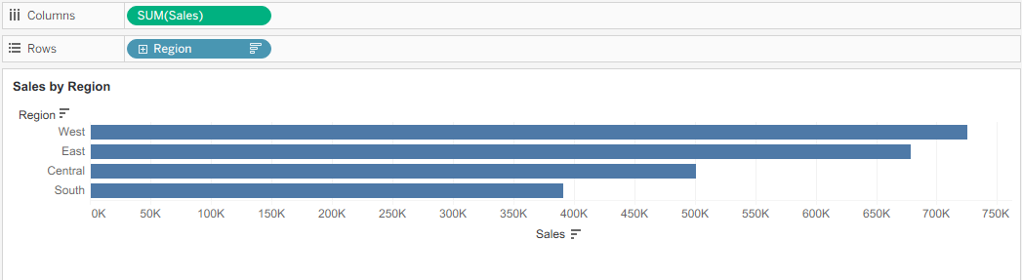
Profit Trend Over Time (Line Chart): The chart is essential in determining seasonality. Examining the spikes and dips in 2021 and 2022 enables the executives to adjust their capital expenditure (CAPEX) in relation to high cash flow levels.
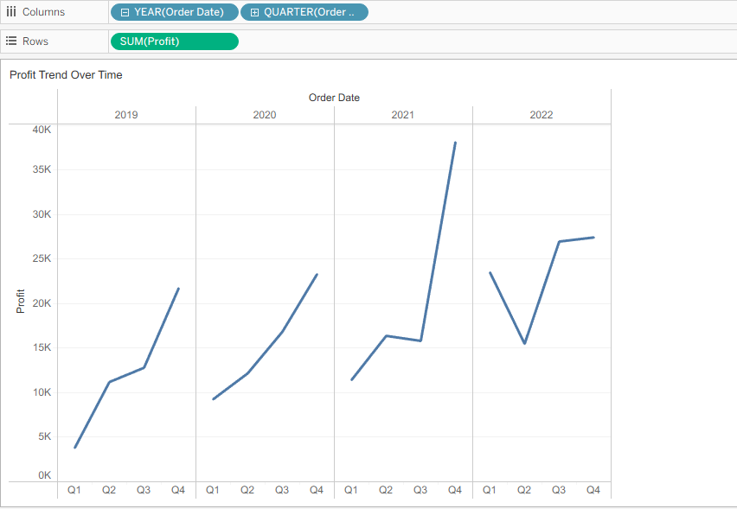
Sales vs. Profit (Scatter Plot): It is probably the most strategic image. It charts each transaction/product. Outliers on the right hand side bottom quadrant denote the items that have the characteristics of High Sales, Low Profit- the most dangerous products in the store.
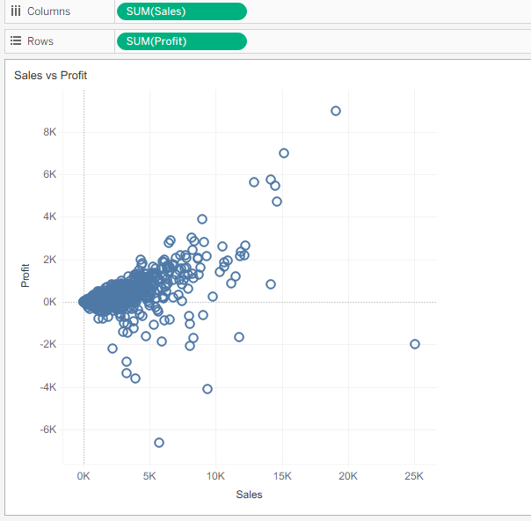

4.3 Conclusion
This evaluation demonstrates that information-based storytelling becomes crucial in the contemporary executive decision-making. We have given the board the clear picture of the organizational health by critically evaluating the Sample Superstore dashboard and implementing higher quality strategic visualizations, namely, Regional Bar Charts, Profit Trends, and Sales-Profit Scatter Plots. The transition of descriptive analytics (seeing what happened) to predictive analytics (seeing what is likely to happen) is no longer an option, but a strategic need in a competitive retail environment.
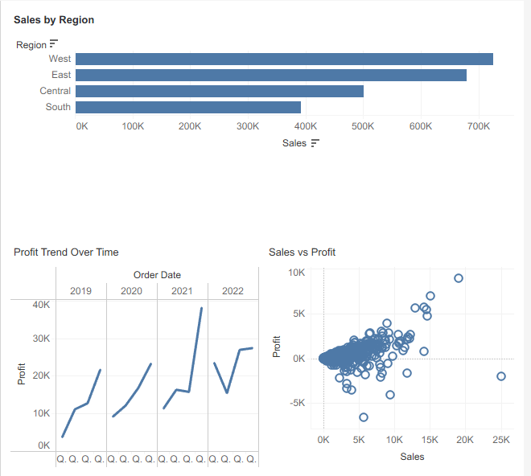
Although such issues as data quality and algorithmic bias have to be dealt with proactively, they are compensated by far more elevated returns of evidence-based leadership. The organization will ensure its way towards becoming a truly AI-enabled, high-performance boardroom by regional strength maximization, eradication of operational risks with the help of granular analysis, and adherence to the suggested AI roadmap. The roadmap of sustainable profitability is the ultimate one that goes through raw data to actionable insights.

References (APA Style)
- Anderson, E., & Zettelmeyer, F. (2020). Leading with AI and Analytics. McGraw-Hill.
- Gressel, S., Pauleen, D., & Taskin, N. (2020). Management Decision-Making, Big Data and Analytics. SAGE Publications.
- Few, S. (2013). Information Dashboard Design. O'Reilly Media.
- Davenport, T. H. (2018). The AI Advantage. MIT Press.
- Knaflic, C. N. (2015). Storytelling with Data. Wiley.

